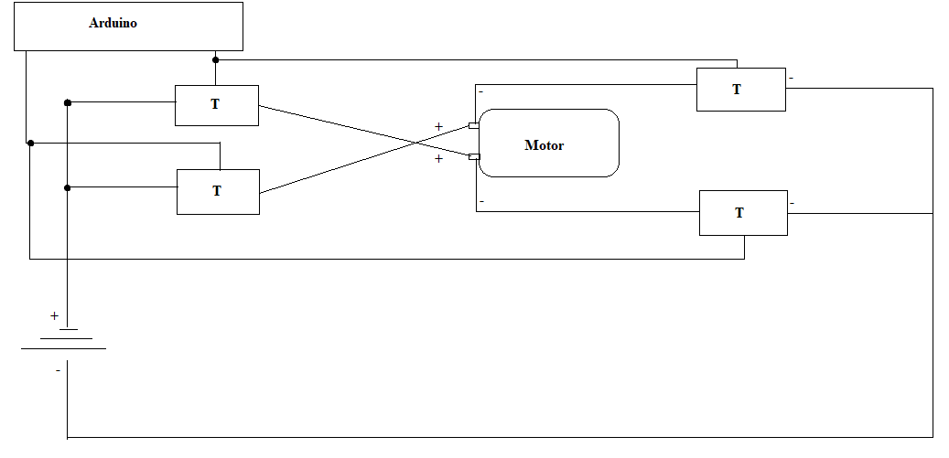

This could be done for both ends, if I use 2 motors (one at each end)